MICROSOFT PROJECT MANUAL-1

Punjab University College Of Information Technology

1 PROJECT MANAGEMENT
Project management is the process of planning, organizing, and managing tasks and resources to accomplish a defined objective, usually within constraints on time, resources, or cost. A project plan complexity level is of hybrid nature. There are simple projects containing few activities and can be managed on registers and there are projects which contain a large number of activities, having complex dependencies on each other, or possessing a hefty number of variables such as resources or costs. Such projects can make project planning an uphill journey and make project managers sweat like this.

Project Management Tools are basically helping the managers to deal with the wide range set of tasks associated with thousands of variables, in an automated way, by virtue of which they can attain the objectives of
- Organized schedule of all the project details
- Tracking the project activities with reference to the variables mentioned above
Microsoft Project is one of these Project Management tools. And we are using it in our course of case tools because it is widely practiced in the software development facilities, both locally and globally. The aim is to give you extensive hands on knowledge of this tool so that you can use it with the theoretical concepts of project management in order to manage your software development activities.
1.1 The Project Triangle
Every project is basically governed by three critical factors
Time | The time to complete the project
Money | The project budget, based on the cost of the resources: the people, equipment, and materials required to do the tasks.
Scope | The goals and tasks of the project and the work required to complete them.
You will be using Microsoft Project with reference to these three factors.

2 Starting Microsoft Project
Whenever you start Microsoft Project, the first thing that you will see is given below
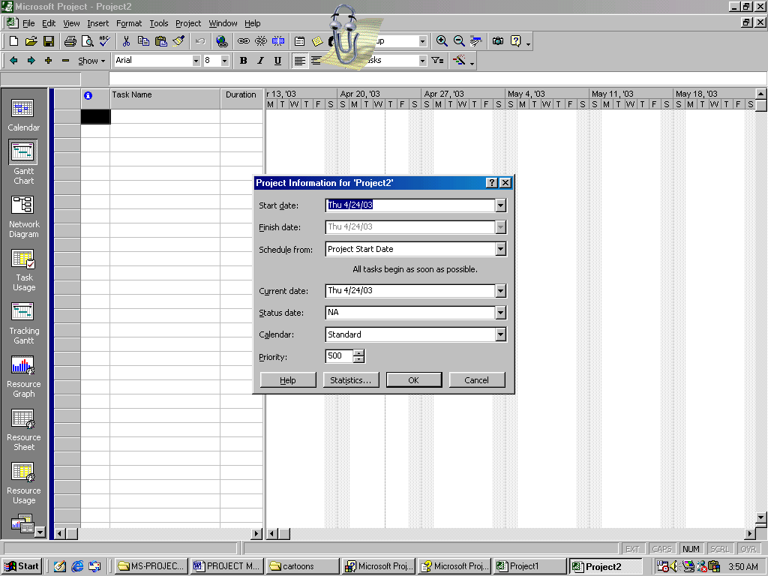

1
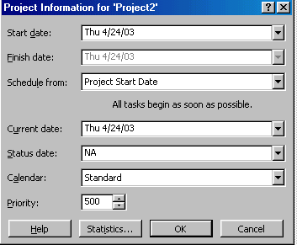
2
3
(Project Information Dialog Box)

2.1 Project Information dialog box
If you want to open this dialog manually, then go to Project menu and click Project Information.
Use this dialog box to enter, review, or change initial information for a new project. You can:
- Choose whether you want the project to be scheduled from the start date or the finish date.
- Enter the start date for a project to be scheduled from the start date.
- Enter the finish date for a project to be scheduled from the finish date.
- Specify which base calendar is to be used as the project calendar.
- Obtain overall project statistics for start and finish dates, duration, work, and cost.
Details The following are details about the default base calendars in the Calendar list. If you create additional base calendars, or if you modify the working times in the existing base calendars, these become available in the Calendar list as well.
Standard The base calendar that has a standard work day and work week of Monday through Friday, 8:00 A.M. to 5:00 P.M., with 12:00 P.M. to 1:00 P.M non working times for a break.
24 Hours The base calendar that has no nonworking time. All time, from Sunday through Saturday, 12:00 A.M. to 12:00 P.M., is set as working time.
Night Shift The base calendar that is set up for a graveyard shift. Working times are Monday night through Saturday morning, 11:00 P.M. to 8:00 A.M., with 3:00 A.M. to 4:00 A.M. of nonworking time for a break.
If you choose to schedule from the start date, the Finish date box becomes unavailable. You set the start date, which by default is today's date, and Microsoft Project calculates the finish date based on your task information.
Likewise, if you choose to schedule from the finish date, the Start date box becomes unavailable. You set the finish date, and Microsoft Project calculates the start date based on your task information.
Also, if you schedule from the start date, all new tasks have a default constraint type of As Soon As Possible (ASAP). If you schedule from the finish date, all new tasks have a default constraint type of As Late As Possible (ALAP).

3 Planning Project Activities
Planning project activities revolves around the determination of the following key aspects
Define project objectives so that all project stakeholders understand clearly what your project is expected to accomplish.
Define project assumptions so that all project stakeholders have the opportunity to approve the assumptions underlying your project (for example, the availability of your resources or the basis of your task duration estimates).
Define project constraints so that all project stakeholders are aware of the factors that may limit their options later in the project. Defining constraints allows stakeholders to plan for solutions to possible problems, such as reducing the labor force if labor costs turn out to be higher than expected.
Prepare a scope management plan so that if any part of the project's scope, which includes all project goals and tasks, is changed in the course of the project, the stakeholders can review a plan that describes how you might adapt the project for changes you anticipate.
After fixing the above divulged factors, you just organize the work involved into
Milestones | A reference point marking a major event in a project and used to monitor the project's progress. Any task with zero duration is automatically displayed as a milestone; you can also mark any other task of any duration a milestone.
Phases | A group of related tasks that completes a major step in a project.
Tasks | An activity that has a beginning and an ending. The completion of a task is important to the project's completion. Projects are made up of tasks.
And start entering it into the Microsoft Project File.
  - Entering Tasks
There are two types of tasks that you will encounter with
- Tasks that occurs once
- Recurring Tasks
1 |  | On the View menu, click Gantt Chart.
2 |  | In the Task Name field, type a task name.

3 |  | Press ENTER.

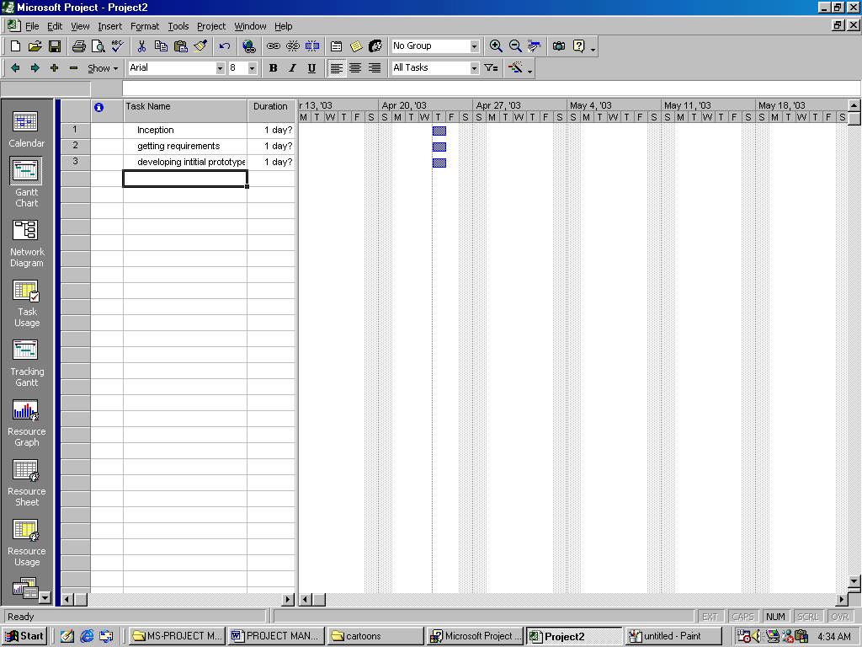

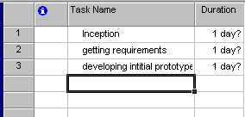
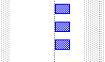
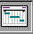

NOTE
You can see on this Gantt Chart that there are some gray areas. These gray areas basically reflect your non working days and your project will not be scheduled around these days by default.

For Recurring tasks that is the tasks that will be of same nature, follow the following mentioned steps
1 | In the Task Name field, select the row below where you want the recurring task to appear.

2 |  | On the Insert menu, click Recurring Task.

3 |  | In the Task Name box, type the task name.

4 |  | In the Duration box, type the duration of a single occurrence of the task.

5 |  | Under Recurrence pattern, click Daily, Weekly, Monthly, or Yearly.

6 |  | To the right of Daily, Weekly, Monthly, or Yearly, specify the task frequency.

7 |  | Under Range of recurrence, type a start date in the Start box, and then select End after or End by.

8 |  | If you selected End after, type the number of occurrences for the task.  If you selected End by, type the date you want the recurring task to end.

  - Identifying Phases
You know that phases are the collection of related tasks. You can represent a phase in Microsoft Project by indenting the tasks coming under that phase. When you will be doing this, the representation of a phase on the Gantt chart will be as


  - Identifying Milestones
1 |  | On the View menu, click Gantt Chart.

2 |  | Type 0 in the Duration field of the task you want to change.

3 |  | Press ENTER.

Some milestones may need duration. For example, your project has an approval milestone at the end of a phase and you know that the approval process will take a week. To mark a task as a milestone with duration of more than 0 days, click Task Information, and then click the Advanced tab. In the Duration box, enter the task duration, and then select the Mark task as milestone check box.
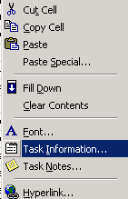

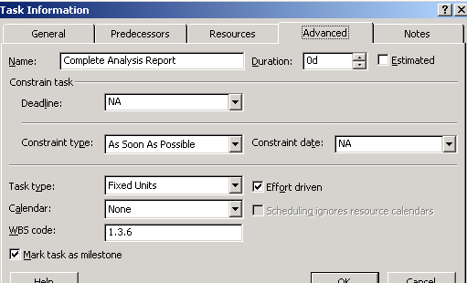

  - Identify Duration

Allocate duration to each task/subtask as per requirement under your plan by clicking on the duration cells in front of each task/subtask. As shown below
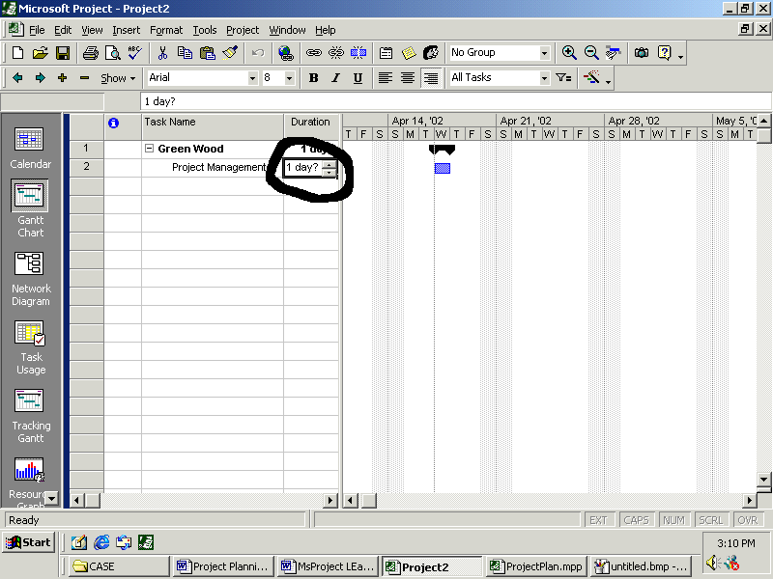
………………….To be continued………………………………

